# Capstone Project – Finding Best Places to open new Chinese Restaurant

## 1- Introduction

Toronto is a Large Metropoly with diverse population. This diversity also means a diversity in cuture. As any other large multicultural city, Toronto has high demand for cultural food to satisfy its population.

With this in mind we seek to find the best place for new culture restaurants. In this example we will use Chinese food as a guideline, but this core idea can be used for any other cuisine or service.

First we have to address our problems and goals:

* List all Chinese Restaurant in Toronto and each neighborhood
* Find places where ther is lacking nearby Chinese Restaurant
* Find places for potential new Chinese Restaurant

## 2- Data

For this example, I will use Toronto as baseline, but it can be use with any city that exist in Foursquare database.

I will use more venues' informations than previous projects, such as price, popularity, if its clean or if its require any dress code.

Following data sources will be needed to extract/generate the required information:

* centers of areas will be generated algorithmically and approximate addresses of centers of those areas will be obtained using **Google Maps API reverse geocoding**
* information about restaurants as their type and location in every neighborhood will be obtained using **Foursquare API**
* coordinate of Toronto's neighborhoods will be obtained using **Google Maps API geocoding**

## 3- Methodology

In this project we will direct our efforts on detecting areas of Toronto that have low restaurant density, particularly those with low number of Chinese restaurants. We will limit our analysis to area ~6km around city center.

In first step we have collected the required data: location and type (category) of every restaurant within 6km from Toronto Town Hall. We have also identified Chinese restaurants (according to Foursquare categorization).

Second step in our analysis will be calculation and exploration of 'restaurant density' across different areas of Toronto - we will use heatmaps to identify a few promising areas close to center with low number of restaurants in general (and no Chinese restaurants in vicinity) and focus our attention on those areas.

In third and final step we will focus on most promising areas and within those create clusters of locations that meet some basic requirements established in discussion with stakeholders: we will take into consideration locations with no more than two restaurants in radius of 250 meters, and we want locations without Chinese restaurants in radius of 400 meters. We will present map of all such locations but also create clusters (using k-means clustering) of those locations to identify general zones / neighborhoods / addresses which should be a starting point for final 'street level' exploration and search for optimal venue location by stakeholders.

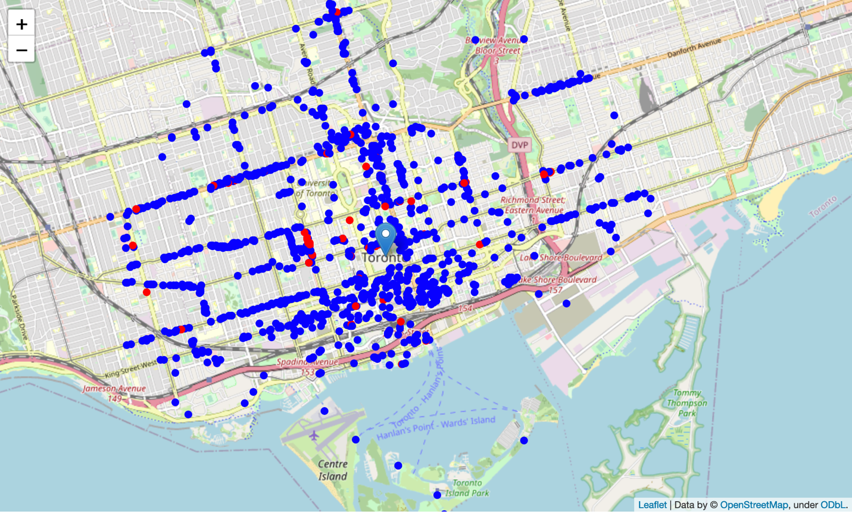

Figure 1 – All Restaurants around Toronto City Hall, red dots are Chinese Restaurant

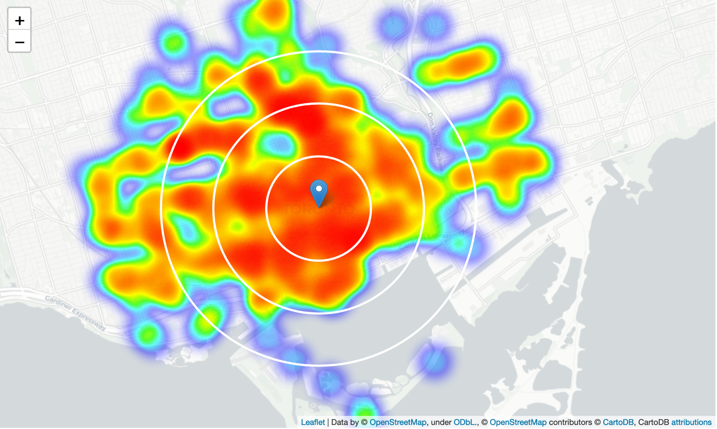

Figure 2 – Heatmap of all restaurants

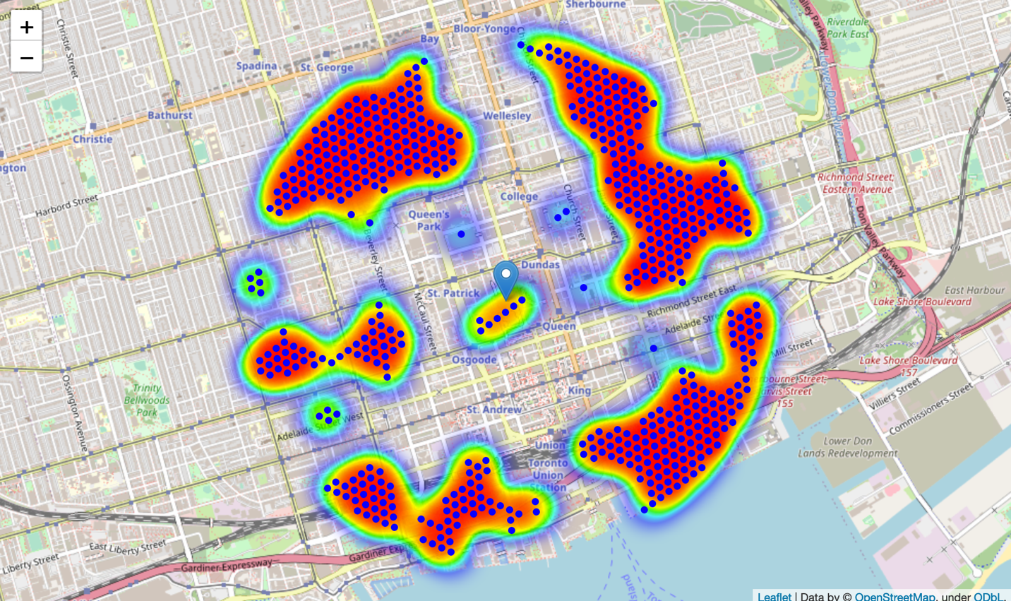

Figure 3 – Possible Locations for new restaurant

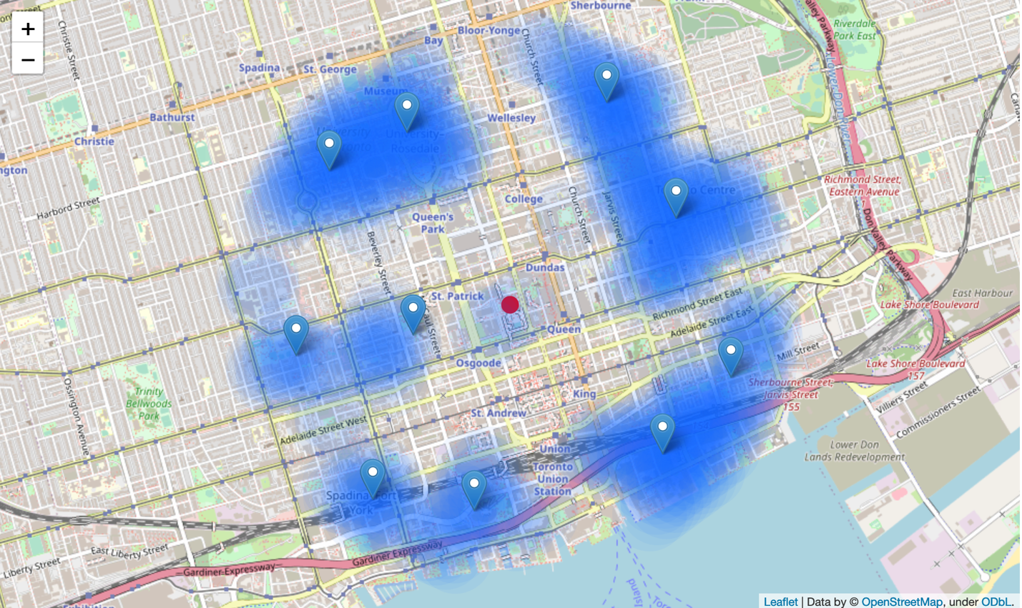

Figure 4 – Optimal areas for further investigation

## 4- Results and Discussion

Our analysis shows that although there is a great number of restaurants in Toronto (~1000 in our initial area of interest which was 12x12km around City Hall), there are pockets of low restaurant density fairly close to city center. Highest concentration of restaurants was detected south(east and west) and north from City Hall, so we focused our attention to areas south, south-east and north-east.

After directing our attention to this more narrow area of interest we first created a dense grid of location candidates (spaced 100m appart); those locations were then filtered so that those with more than two restaurants in radius of 250m and those with an Chinese restaurant closer than 400m were removed.

Those location candidates were then clustered to create zones of interest which contain greatest number of location candidates. Addresses of centers of those zones were also generated using reverse geocoding to be used as markers/starting points for more detailed local analysis based on other factors.

Result of all this is 15 zones containing largest number of potential new restaurant locations based on number of and distance to existing venues - both restaurants in general and Chinese restaurants particularly. This, of course, does not imply that those zones are actually optimal locations for a new restaurant! Purpose of this analysis was to only provide info on areas close to Toronto City Hall but not crowded with existing restaurants (particularly Chinese) - it is entirely possible that there is a very good reason for small number of restaurants in any of those areas, reasons which would make them unsuitable for a new restaurant regardless of lack of competition in the area. Recommended zones should therefore be considered only as a starting point for more detailed analysis which could eventually result in location which has not only no nearby competition but also other factors taken into account and all other relevant conditions met.

## 5- Conclusion

Purpose of this project was to identify Toronto areas close to center with low number of restaurants (particularly Chinese restaurants) in order to aid stakeholders in narrowing down the search for optimal location for a new Chinese restaurant. By calculating restaurant density distribution from Foursquare data we have first identified general boroughs that justify further analysis, and then generated extensive collection of locations which satisfy some basic requirements regarding existing nearby restaurants. Clustering of those locations was then performed in order to create major zones of interest (containing greatest number of potential locations) and addresses of those zone centers were created to be used as starting points for final exploration by stakeholders.

**Final decission on optimal restaurant location will be made by stakeholders** based on specific characteristics of neighborhoods and locations in every recommended zone, taking into consideration additional factors like attractiveness of each location (proximity to park or water), levels of noise / proximity to major roads, real estate availability, prices, social and economic dynamics of every neighborhood etc.